Table Styles
Table styles are responsible for the rapid formatting that can be applied to a table. This rapid formatting takes different parts of a table into account, such as if the first row or last row should be emphasized, or if there is some type of banding (row for example) present on the table. All of these different types of formatting can be defined within a table style

band1H (Band 1 Horizontal)
This element describes the formatting for the first row in horizontal banding. Two different row formatting are applied to the table alternating in order to create a banding effect on the table.
[Example: Consider the following example of band 1 horizontal being used within DrawingML:
<band1H>
<tcStyle>
<tcBdr/>
<fill>
<solidFill>
<schemeClr val="accent1">
<tint val="40000"/>
</schemeClr>
</solidFill>
</fill>
</tcStyle>
</band1H>
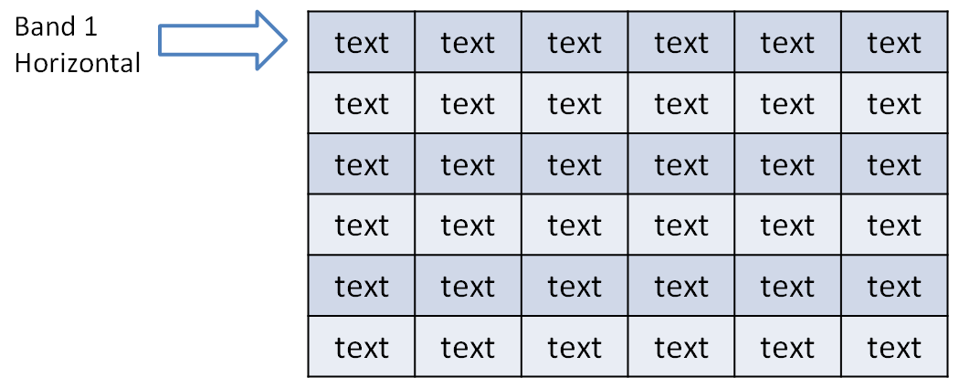
In this example, we set the fill to be a solid fill referencing the accent 1 color defined in the theme. end example]
Parent Elements
tableStyle (§5.1.6.9); tblStyle (§5.1.4.2.26)

Child Elements | Subclause
tcStyle (Table Cell Style) | §5.1.4.2.29
tcTxStyle (Table Cell Text Style) | §5.1.4.2.30
The following XML Schema fragment defines the contents of this element:
<complexType name="CT_TablePartStyle">
<sequence>
<element name="tcTxStyle" type="CT_TableStyleTextStyle" minOccurs="0" maxOccurs="1"/>
<element name="tcStyle" type="CT_TableStyleCellStyle" minOccurs="0" maxOccurs="1"/>
</sequence>
</complexType>

band1V (Band 1 Vertical)
This element describes the formatting for the first row in vertical banding. Two different row formatting are applied to the table alternating in order to create a banding effect on the table.
[Example: Consider the following example of band 1 vertical being used within DrawingML:
<band1V>
<tcStyle>
<tcBdr/>
<fill>
<solidFill>
<schemeClr val="accent1">
<tint val="40000"/>
</schemeClr>
</solidFill>
</fill>
</tcStyle>
</band1V>
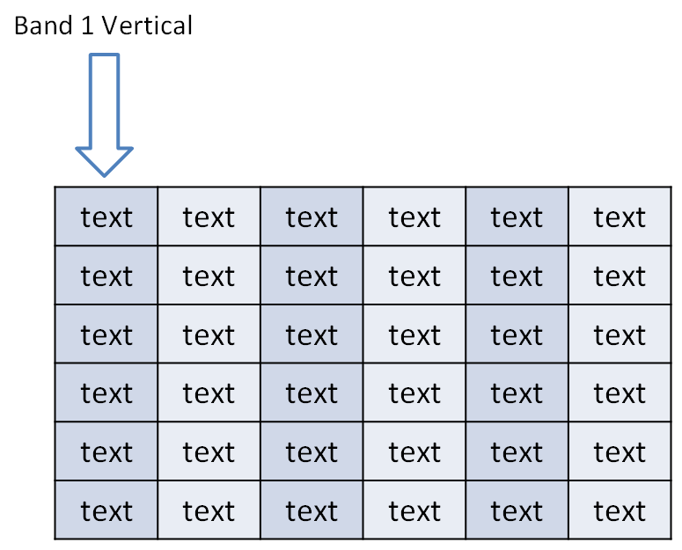
In this example, we set the fill to be a solid fill referencing the accent 1 color defined in the theme. end example]
Parent Elements
tableStyle (§5.1.6.9); tblStyle (§5.1.4.2.26)

Child Elements | Subclause
tcStyle (Table Cell Style) | §5.1.4.2.29
tcTxStyle (Table Cell Text Style) | §5.1.4.2.30
The following XML Schema fragment defines the contents of this element:
<complexType name="CT_TablePartStyle">
<sequence>
<element name="tcTxStyle" type="CT_TableStyleTextStyle" minOccurs="0" maxOccurs="1"/>
<element name="tcStyle" type="CT_TableStyleCellStyle" minOccurs="0" maxOccurs="1"/>
</sequence>
</complexType>

band2H (Band 2 Horizontal)
This element describes the formatting for the second row in horizontal banding. Two different row formatting are applied to the table alternating in order to create a banding effect on the table.
[Example: Consider the following example of band 2 horizontal being used within DrawingML:
<band2H>
<tcStyle>
<tcBdr/>
<fill>
<solidFill>
<schemeClr val="accent2">
<tint val="40000"/>
</schemeClr>
</solidFill>
</fill>
</tcStyle>
</band2H>
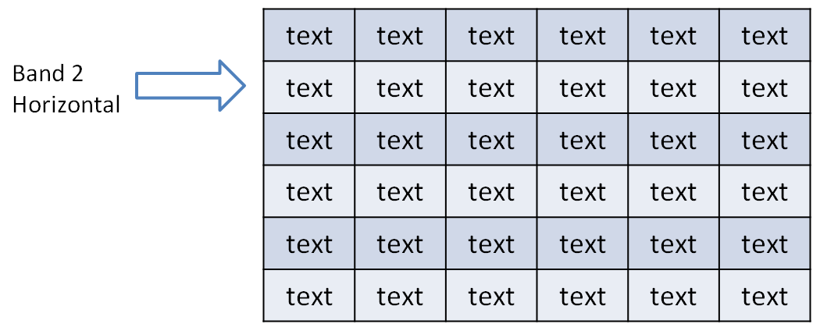
In this example, we set the fill to be a solid fill referencing the accent 2 color defined in the theme. end example]
Parent Elements
tableStyle (§5.1.6.9); tblStyle (§5.1.4.2.26)

Child Elements | Subclause
tcStyle (Table Cell Style) | §5.1.4.2.29
tcTxStyle (Table Cell Text Style) | §5.1.4.2.30
The following XML Schema fragment defines the contents of this element:
<complexType name="CT_TablePartStyle">
<sequence>
<element name="tcTxStyle" type="CT_TableStyleTextStyle" minOccurs="0" maxOccurs="1"/>
<element name="tcStyle" type="CT_TableStyleCellStyle" minOccurs="0" maxOccurs="1"/>
</sequence>
</complexType>

band2V (Band 2 Vertical)
This element describes the formatting for the second row in vertical banding. Two different row formatting are applied to the table alternating in order to create a banding effect on the table.
[Example: Consider the following example of band 2 vertical being used within DrawingML:
<band2V>
<tcStyle>
<tcBdr/>
<fill>
<solidFill>
<schemeClr val="accent2">
<tint val="40000"/>
</schemeClr>
</solidFill>
</fill>
</tcStyle>
</band2V>
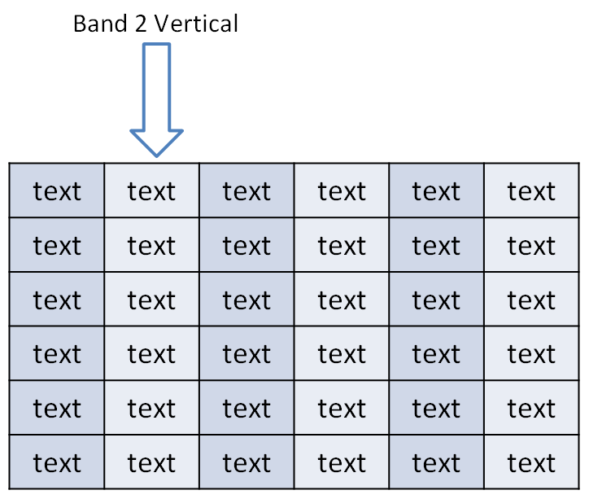
In this example, we set the fill to be a solid fill referencing the accent 2 color defined in the theme. end example]
Parent Elements
tableStyle (§5.1.6.9); tblStyle (§5.1.4.2.26)

Child Elements | Subclause
tcStyle (Table Cell Style) | §5.1.4.2.29
tcTxStyle (Table Cell Text Style) | §5.1.4.2.30
The following XML Schema fragment defines the contents of this element:
<complexType name="CT_TablePartStyle">
<sequence>
<element name="tcTxStyle" type="CT_TableStyleTextStyle" minOccurs="0" maxOccurs="1"/>
<element name="tcStyle" type="CT_TableStyleCellStyle" minOccurs="0" maxOccurs="1"/>
</sequence>
</complexType>

bevel (Bevel)
This element defines the properties of the bevel associated with the 3D effect applied to a cell in a table.
Parent Elements
cell3D (§5.1.6.1)

Attributes | Description
h (Height) | Specifies the height of the bevel, or how far above the shape it is applied.  [Example: Consider the following example bevel  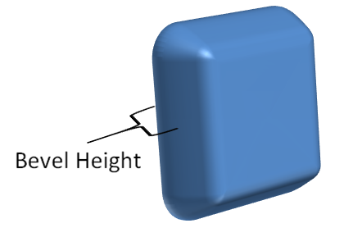  In this example, we see the height of an example bevel on a shape. end example]  The possible values for this attribute are defined by the ST_PositiveCoordinate simple type (§5.1.12.42).
prst (Preset Bevel) | Specifies the preset bevel type which defines the look of the bevel.  The possible values for this attribute are defined by the ST_BevelPresetType simple type (§5.1.12.9).
w (Width) | Specifies the width of the bevel, or how far into the shape it is applied.  [Example: Consider the following example bevel  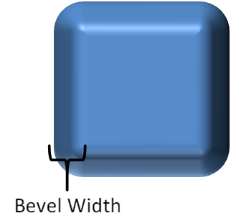  In this example, we see the width of an example bevel on a shape. end example]  The possible values for this attribute are defined by the ST_PositiveCoordinate simple type (§5.1.12.42).
The following XML Schema fragment defines the contents of this element:
<complexType name="CT_Bevel">
<attribute name="w" type="ST_PositiveCoordinate" use="optional" default="76200"/>
<attribute name="h" type="ST_PositiveCoordinate" use="optional" default="76200"/>
<attribute name="prst" type="ST_BevelPresetType" use="optional" default="circle"/>
</complexType>

bottom (Bottom Border)
This element defines the line properties associated with the bottom border in a table cell.
[Example: Consider the following example of the bottom border in use within DrawingML:
<bottom>
<ln w="12700" cmpd="sng">
<solidFill>
<schemeClr val="accent1"/>
</solidFill>
</ln>
</bottom>
In this example, we see the bottom border on a table cell to be a single 1pt line which is colored accent 1. end example]
Parent Elements
tcBdr (§5.1.4.2.28)

Child Elements | Subclause
ln (Outline) | §5.1.2.1.24
lnRef (Line Reference) | §5.1.4.2.19
The following XML Schema fragment defines the contents of this element:
<complexType name="CT_ThemeableLineStyle">
<choice>
<element name="ln" type="CT_LineProperties" minOccurs="1" maxOccurs="1"/>
<element name="lnRef" type="CT_StyleMatrixReference" minOccurs="1" maxOccurs="1"/>
</choice>
</complexType>

effect (Effect)
This element defines the effect that can be applied to a table as a whole through a table style.
[Example: Consider the following example of an effect in use within DrawingML:
<effect>
<effectLst>
<glow rad="228600">
<schemeClr val="accent1">
<satMod val="175000"/>
<alpha val="40000"/>
</schemeClr>
</glow>
</effectLst>
</effect>
In this example, we see a glow being defined within the table style that will be applied to the table as a whole. end example]
Parent Elements
tblBg (§5.1.4.2.25)

Child Elements | Subclause
effectDag (Effect Container) | §5.1.10.25
effectLst (Effect Container) | §5.1.10.26
The following XML Schema fragment defines the contents of this element:
<complexType name="CT_EffectProperties">
<sequence>
<group ref="EG_EffectProperties" minOccurs="1" maxOccurs="1"/>
</sequence>
</complexType>

effectRef (Effect Reference)
This element defines a reference to an effect style within the style matrix. The idx attribute refers the index of an effect style within the effectStyleLst element.
Parent Elements
style (§5.6.2.30); style (§5.9.2.28); style (§4.4.1.43); style (§5.8.2.24); style (§5.1.2.1.37); tblBg (§5.1.4.2.25)

Child Elements | Subclause
hslClr (Hue, Saturation, Luminance Color Model) | §5.1.2.2.13
prstClr (Preset Color) | §5.1.2.2.22
schemeClr (Scheme Color) | §5.1.2.2.29
scrgbClr (RGB Color Model - Percentage Variant) | §5.1.2.2.30
srgbClr (RGB Color Model - Hex Variant) | §5.1.2.2.32
sysClr (System Color) | §5.1.2.2.33

Attributes | Description
idx (Style Matrix Index) | Specifies the style matrix index of the style referred to.  The possible values for this attribute are defined by the ST_StyleMatrixColumnIndex simple type (§5.1.12.57).
The following XML Schema fragment defines the contents of this element:
<complexType name="CT_StyleMatrixReference">
<sequence>
<group ref="EG_ColorChoice" minOccurs="0" maxOccurs="1"/>
</sequence>
<attribute name="idx" type="ST_StyleMatrixColumnIndex" use="required"/>
</complexType>

fill (Fill)
This element defines the fill that is applied to the table as a whole. The background of the table can contain a single fill that is the entire size of the table. This can allow for gradient fills, or image fills, which span the entire size of the table.
[Example: Consider the following example of a fill on a table background in DrawingML:
<fill>
<gradFill flip="none" rotWithShape="1">
<gsLst>
<gs pos="0">
<schemeClr val="accent2">
<shade val="75000"/>
</schemeClr>
</gs>
<gs pos="100000">
<schemeClr val="accent2">
<shade val="75000"/>
<tint val="20000"/>
</schemeClr>
</gs>
</gsLst>
<lin ang="2700000" scaled="1"/>
<tileRect/>
</gradFill>
</fill>
In this example, we apply a gradient fill to the entire table on the background shape of the table. end example]
Parent Elements
tblBg (§5.1.4.2.25); tcStyle (§5.1.4.2.29)

Child Elements | Subclause
blipFill (Picture Fill) | §5.1.10.14
gradFill (Gradient Fill) | §5.1.10.33
grpFill (Group Fill) | §5.1.10.35
noFill (No Fill) | §5.1.10.44
pattFill (Pattern Fill) | §5.1.10.47
solidFill (Solid Fill) | §5.1.10.54
The following XML Schema fragment defines the contents of this element:
<complexType name="CT_FillProperties">
<sequence>
<group ref="EG_FillProperties" minOccurs="1" maxOccurs="1"/>
</sequence>
</complexType>

fillRef (Fill Reference)
This element defines a reference to a fill style within the style matrix. The idx attribute refers to the index of a fill style or background fill style within the presentation's style matrix, defined by the fmtScheme element. A value of 0 or 1000 indicates no background, values 1-999 refer to the index of a fill style within the fillStyleLst element, and values 1001 and above refer to the index of a background fill style within the bgFillStyleLst element. The value 1001 corresponds to the first background fill style, 1002 to the second background fill style, and so on.
[Example:
<a:fillRef idx="2">
<a:schemeClr val="accent2"/>
</a:fillRef>
The above code indicates the object is to have the style's second fill style using the accent2 color of the color scheme.
end example]
[Example:
<a:fillRef idx="1001">
<a:schemeClr val="accent2"/>
</a:fillRef>
The above code indicates the object is to have the style's first background fill style using the accent2 color of the color scheme.
end example]
Parent Elements
style (§5.6.2.30); style (§5.9.2.28); style (§4.4.1.43); style (§5.8.2.24); style (§5.1.2.1.37); tblBg (§5.1.4.2.25); tcStyle (§5.1.4.2.29)

Child Elements | Subclause
hslClr (Hue, Saturation, Luminance Color Model) | §5.1.2.2.13
prstClr (Preset Color) | §5.1.2.2.22
schemeClr (Scheme Color) | §5.1.2.2.29
scrgbClr (RGB Color Model - Percentage Variant) | §5.1.2.2.30
srgbClr (RGB Color Model - Hex Variant) | §5.1.2.2.32
sysClr (System Color) | §5.1.2.2.33

Attributes | Description
idx (Style Matrix Index) | Specifies the style matrix index of the style referred to.  The possible values for this attribute are defined by the ST_StyleMatrixColumnIndex simple type (§5.1.12.57).
The following XML Schema fragment defines the contents of this element:
<complexType name="CT_StyleMatrixReference">
<sequence>
<group ref="EG_ColorChoice" minOccurs="0" maxOccurs="1"/>
</sequence>
<attribute name="idx" type="ST_StyleMatrixColumnIndex" use="required"/>
</complexType>

firstCol (First Column)
This element defines the cell formatting which can be applied to the first column of the table.
[Example: Consider the following example of first column formatting within DrawingML:
<firstCol>
<tcTxStyle b="on">
<fontRef idx="minor">
<scrgbClr r="0" g="0" b="0"/>
</fontRef>
<schemeClr val="lt1"/>
</tcTxStyle>
<tcStyle>
<tcBdr/>
<fill>
<solidFill>
<schemeClr val="accent1"/>
</solidFill>
</fill>
</tcStyle>
</firstCol>
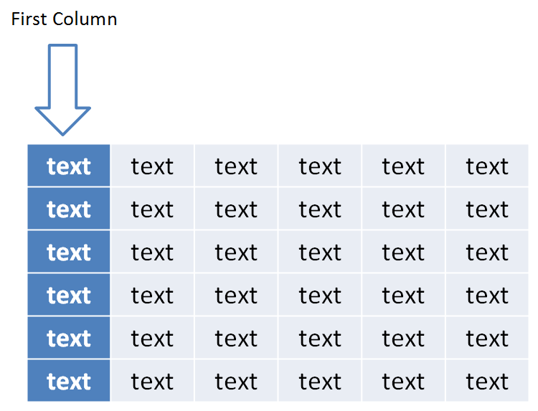
In this example, we define the first column cell fills to be accent 1 along with the text properties to be bold when first column formatting is enabled through the user interface. end example]
Parent Elements
tableStyle (§5.1.6.9); tblStyle (§5.1.4.2.26)

Child Elements | Subclause
tcStyle (Table Cell Style) | §5.1.4.2.29
tcTxStyle (Table Cell Text Style) | §5.1.4.2.30
The following XML Schema fragment defines the contents of this element:
<complexType name="CT_TablePartStyle">
<sequence>
<element name="tcTxStyle" type="CT_TableStyleTextStyle" minOccurs="0" maxOccurs="1"/>
<element name="tcStyle" type="CT_TableStyleCellStyle" minOccurs="0" maxOccurs="1"/>
</sequence>
</complexType>

firstRow (First Row)
This element defines the cell formatting which can be applied to the first row of the table.
[Example: Consider the following example of first row formatting within DrawingML:
<firstRow>
<tcTxStyle b="on">
<fontRef idx="minor">
<scrgbClr r="0" g="0" b="0"/>
</fontRef>
<schemeClr val="lt1"/>
</tcTxStyle>
<tcStyle>
<tcBdr/>
<fill>
<solidFill>
<schemeClr val="accent1"/>
</solidFill>
</fill>
</tcStyle>
</firstRow>
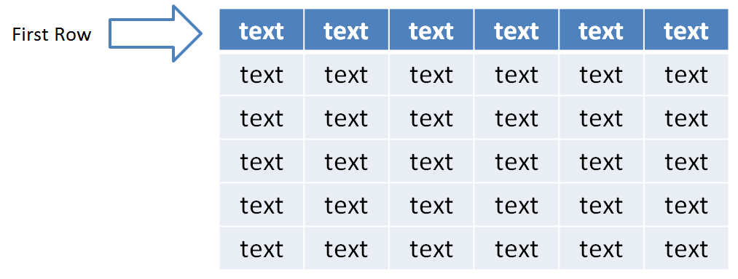
In this example, we define the first row cell fills to be accent 1 along with the text properties to be bold when first row formatting is enabled through the user interface. end example]
Parent Elements
tableStyle (§5.1.6.9); tblStyle (§5.1.4.2.26)

Child Elements | Subclause
tcStyle (Table Cell Style) | §5.1.4.2.29
tcTxStyle (Table Cell Text Style) | §5.1.4.2.30
The following XML Schema fragment defines the contents of this element:
<complexType name="CT_TablePartStyle">
<sequence>
<element name="tcTxStyle" type="CT_TableStyleTextStyle" minOccurs="0" maxOccurs="1"/>
<element name="tcStyle" type="CT_TableStyleCellStyle" minOccurs="0" maxOccurs="1"/>
</sequence>
</complexType>

font (Font)
This element defines the font to be used within a given table cell text style. This element allows for exact definition of the font within the table style instead of referencing a themed font.
Parent Elements
tcTxStyle (§5.1.4.2.30)

Child Elements | Subclause
cs (Complex Script Font) | §5.1.5.3.1
ea (East Asian Font) | §5.1.5.3.3
extLst (Extension List) | §5.1.2.1.15
font (Font) | §5.1.4.1.16
latin (Latin Font) | §5.1.5.3.7
The following XML Schema fragment defines the contents of this element:
<complexType name="CT_FontCollection">
<sequence>
<element name="latin" type="CT_TextFont" minOccurs="1" maxOccurs="1"/>
<element name="ea" type="CT_TextFont" minOccurs="1" maxOccurs="1"/>
<element name="cs" type="CT_TextFont" minOccurs="1" maxOccurs="1"/>
<element name="font" type="CT_SupplementalFont" minOccurs="0" maxOccurs="unbounded"/>
<element name="extLst" type="CT_OfficeArtExtensionList" minOccurs="0" maxOccurs="1"/>
</sequence>
</complexType>

insideH (Inside Horizontal Border)
This element defines the line properties associated with the inner horizontal borders in a table.
[Example: Consider the following example of the inner horizontal borders in use within DrawingML:
<insideH>
<ln w="12700" cmpd="sng">
<solidFill>
<schemeClr val="accent1"/>
</solidFill>
</ln>
</insideH>
In this example, we see the inner horizontal borders in a table to be a single 1pt line which is colored accent 1. end example]
Parent Elements
tcBdr (§5.1.4.2.28)

Child Elements | Subclause
ln (Outline) | §5.1.2.1.24
lnRef (Line Reference) | §5.1.4.2.19
The following XML Schema fragment defines the contents of this element:
<complexType name="CT_ThemeableLineStyle">
<choice>
<element name="ln" type="CT_LineProperties" minOccurs="1" maxOccurs="1"/>
<element name="lnRef" type="CT_StyleMatrixReference" minOccurs="1" maxOccurs="1"/>
</choice>
</complexType>

insideV (Inside Vertical Border)
This element defines the line properties associated with the inner vertical borders in a table.
[Example: Consider the following example of the inside vertical borders in use within DrawingML:
<insideV>
<ln w="12700" cmpd="sng">
<solidFill>
<schemeClr val="accent1"/>
</solidFill>
</ln>
</insideV>
In this example, we see the inner vertical borders in a table to be a single 1pt line which is colored accent 1. end example]
Parent Elements
tcBdr (§5.1.4.2.28)

Child Elements | Subclause
ln (Outline) | §5.1.2.1.24
lnRef (Line Reference) | §5.1.4.2.19
The following XML Schema fragment defines the contents of this element:
<complexType name="CT_ThemeableLineStyle">
<choice>
<element name="ln" type="CT_LineProperties" minOccurs="1" maxOccurs="1"/>
<element name="lnRef" type="CT_StyleMatrixReference" minOccurs="1" maxOccurs="1"/>
</choice>
</complexType>

lastCol (Last Column)
This element defines the cell formatting which can be applied to the last column of the table.
[Example: Consider the following example of last column formatting within DrawingML:
<lastCol>
<tcTxStyle b="on">
<fontRef idx="minor">
<scrgbClr r="0" g="0" b="0"/>
</fontRef>
<schemeClr val="lt1"/>
</tcTxStyle>
<tcStyle>
<tcBdr/>
<fill>
<solidFill>
<schemeClr val="accent1"/>
</solidFill>
</fill>
</tcStyle>
</lastCol>
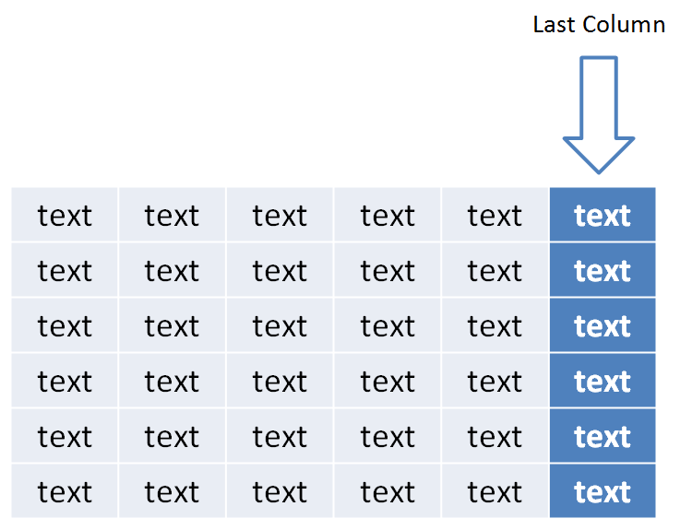
In this example, we define the last column cell fills to be accent 1 along with the text properties to be bold when last column formatting is enabled through the user interface. end example]
Parent Elements
tableStyle (§5.1.6.9); tblStyle (§5.1.4.2.26)

Child Elements | Subclause
tcStyle (Table Cell Style) | §5.1.4.2.29
tcTxStyle (Table Cell Text Style) | §5.1.4.2.30
The following XML Schema fragment defines the contents of this element:
<complexType name="CT_TablePartStyle">
<sequence>
<element name="tcTxStyle" type="CT_TableStyleTextStyle" minOccurs="0" maxOccurs="1"/>
<element name="tcStyle" type="CT_TableStyleCellStyle" minOccurs="0" maxOccurs="1"/>
</sequence>
</complexType>

lastRow (Last Row)
This element defines the cell formatting which can be applied to the last row of the table.
[Example: Consider the following example of last row formatting within DrawingML:
<lastRow>
<tcTxStyle b="on">
<fontRef idx="minor">
<scrgbClr r="0" g="0" b="0"/>
</fontRef>
<schemeClr val="lt1"/>
</tcTxStyle>
<tcStyle>
<tcBdr/>
<fill>
<solidFill>
<schemeClr val="accent1"/>
</solidFill>
</fill>
</tcStyle>
</lastRow>
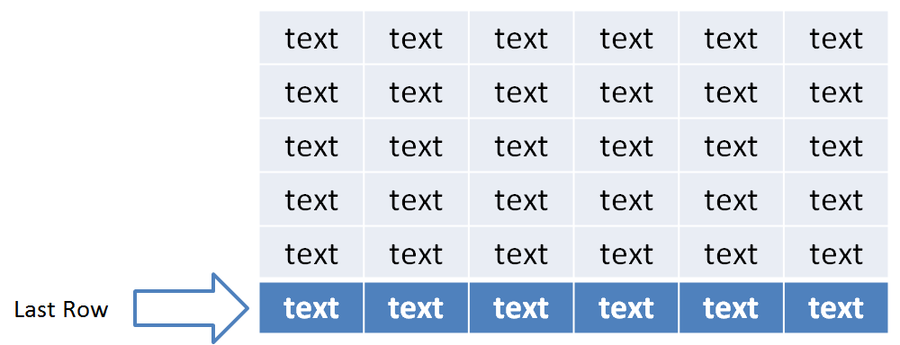
In this example, we define the last row cell fills to be accent 1 along with the text properties to be bold when last row formatting is enabled through the user interface. end example]
Parent Elements
tableStyle (§5.1.6.9); tblStyle (§5.1.4.2.26)

Child Elements | Subclause
tcStyle (Table Cell Style) | §5.1.4.2.29
tcTxStyle (Table Cell Text Style) | §5.1.4.2.30
The following XML Schema fragment defines the contents of this element:
<complexType name="CT_TablePartStyle">
<sequence>
<element name="tcTxStyle" type="CT_TableStyleTextStyle" minOccurs="0" maxOccurs="1"/>
<element name="tcStyle" type="CT_TableStyleCellStyle" minOccurs="0" maxOccurs="1"/>
</sequence>
</complexType>

left (Left Border)
This element defines the line properties associated with the left border in a table cell.
[Example: Consider the following example of the left border in use within DrawingML:
<left>
<ln w="12700" cmpd="sng">
<solidFill>
<schemeClr val="accent1"/>
</solidFill>
</ln>
</left>
In this example, we see the left border on a table cell to be a single 1pt line which is colored accent 1. end example]
Parent Elements
tcBdr (§5.1.4.2.28)

Child Elements | Subclause
ln (Outline) | §5.1.2.1.24
lnRef (Line Reference) | §5.1.4.2.19
The following XML Schema fragment defines the contents of this element:
<complexType name="CT_ThemeableLineStyle">
<choice>
<element name="ln" type="CT_LineProperties" minOccurs="1" maxOccurs="1"/>
<element name="lnRef" type="CT_StyleMatrixReference" minOccurs="1" maxOccurs="1"/>
</choice>
</complexType>

lnRef (Line Reference)
This element defines a reference to a line style within the style matrix. The idx attribute refers the index of a line style within the fillStyleLst element.
Parent Elements
bottom (§5.1.4.2.6); insideH (§5.1.4.2.14); insideV (§5.1.4.2.15); left (§5.1.4.2.18); right (§5.1.4.2.22); style (§5.6.2.30); style (§5.9.2.28); style (§4.4.1.43); style (§5.8.2.24); style (§5.1.2.1.37); tl2br (§5.1.4.2.31); top (§5.1.4.2.32); tr2bl (§5.1.4.2.33)

Child Elements | Subclause
hslClr (Hue, Saturation, Luminance Color Model) | §5.1.2.2.13
prstClr (Preset Color) | §5.1.2.2.22
schemeClr (Scheme Color) | §5.1.2.2.29
scrgbClr (RGB Color Model - Percentage Variant) | §5.1.2.2.30
srgbClr (RGB Color Model - Hex Variant) | §5.1.2.2.32
sysClr (System Color) | §5.1.2.2.33

Attributes | Description
idx (Style Matrix Index) | Specifies the style matrix index of the style referred to.  The possible values for this attribute are defined by the ST_StyleMatrixColumnIndex simple type (§5.1.12.57).
The following XML Schema fragment defines the contents of this element:
<complexType name="CT_StyleMatrixReference">
<sequence>
<group ref="EG_ColorChoice" minOccurs="0" maxOccurs="1"/>
</sequence>
<attribute name="idx" type="ST_StyleMatrixColumnIndex" use="required"/>
</complexType>

neCell (Northeast Cell)
This element defies the formatting for the cell in the northeast corner of a table when both the first row formatting and last column formatting are enabled. This formatting is only applied to the single cell which overlaps between the two formatting options.
[Example: Consider the following example of the northeast cell formatting within DrawingML:
<neCell>
<tcTxStyle b="on">
<fontRef idx="minor">
<scrgbClr r="0" g="0" b="0"/>
</fontRef>
<schemeClr val="lt1"/>
</tcTxStyle>
<tcStyle>
<tcBdr/>
<fill>
<solidFill>
<schemeClr val="accent1"/>
</solidFill>
</fill>
</tcStyle>
</neCell>
In this example, we specifically set the northeast cell to contain bold text with a solid cell fill in the color of accent 1. end example]
Parent Elements
tableStyle (§5.1.6.9); tblStyle (§5.1.4.2.26)

Child Elements | Subclause
tcStyle (Table Cell Style) | §5.1.4.2.29
tcTxStyle (Table Cell Text Style) | §5.1.4.2.30
The following XML Schema fragment defines the contents of this element:
<complexType name="CT_TablePartStyle">
<sequence>
<element name="tcTxStyle" type="CT_TableStyleTextStyle" minOccurs="0" maxOccurs="1"/>
<element name="tcStyle" type="CT_TableStyleCellStyle" minOccurs="0" maxOccurs="1"/>
</sequence>
</complexType>

nwCell (Northwest Cell)
This element defies the formatting for the cell in the northwest corner of a table when both the first row formatting and first column formatting are enabled. This formatting is only applied to the single cell which overlaps between the two formatting options.
[Example: Consider the following example of the northwest cell formatting within DrawingML:
<nwCell>
<tcTxStyle b="on">
<fontRef idx="minor">
<scrgbClr r="0" g="0" b="0"/>
</fontRef>
<schemeClr val="lt1"/>
</tcTxStyle>
<tcStyle>
<tcBdr/>
<fill>
<solidFill>
<schemeClr val="accent1"/>
</solidFill>
</fill>
</tcStyle>
</nwCell>
In this example, we specifically set the northwest cell to contain bold text with a solid cell fill in the color of accent 1. end example]
Parent Elements
tableStyle (§5.1.6.9); tblStyle (§5.1.4.2.26)

Child Elements | Subclause
tcStyle (Table Cell Style) | §5.1.4.2.29
tcTxStyle (Table Cell Text Style) | §5.1.4.2.30
The following XML Schema fragment defines the contents of this element:
<complexType name="CT_TablePartStyle">
<sequence>
<element name="tcTxStyle" type="CT_TableStyleTextStyle" minOccurs="0" maxOccurs="1"/>
<element name="tcStyle" type="CT_TableStyleCellStyle" minOccurs="0" maxOccurs="1"/>
</sequence>
</complexType>

right (Right Border)
This element defines the line properties associated with the right border in a table cell.
[Example: Consider the following example of the right border in use within DrawingML:
<right>
<ln w="12700" cmpd="sng">
<solidFill>
<schemeClr val="accent1"/>
</solidFill>
</ln>
</right>
In this example, we see the right border on a table cell to be a single 1pt line which is colored accent 1. end example]
Parent Elements
tcBdr (§5.1.4.2.28)

Child Elements | Subclause
ln (Outline) | §5.1.2.1.24
lnRef (Line Reference) | §5.1.4.2.19
The following XML Schema fragment defines the contents of this element:
<complexType name="CT_ThemeableLineStyle">
<choice>
<element name="ln" type="CT_LineProperties" minOccurs="1" maxOccurs="1"/>
<element name="lnRef" type="CT_StyleMatrixReference" minOccurs="1" maxOccurs="1"/>
</choice>
</complexType>

seCell (Southeast Cell)
This element defies the formatting for the cell in the southeast corner of a table when both the last row formatting and last column formatting are enabled. This formatting is only applied to the single cell which overlaps between the two formatting options.
[Example: Consider the following example of the southeast cell formatting within DrawingML:
<seCell>
<tcTxStyle b="on">
<fontRef idx="minor">
<scrgbClr r="0" g="0" b="0"/>
</fontRef>
<schemeClr val="lt1"/>
</tcTxStyle>
<tcStyle>
<tcBdr/>
<fill>
<solidFill>
<schemeClr val="accent1"/>
</solidFill>
</fill>
</tcStyle>
</seCell>
In this example, we specifically set the southeast cell to contain bold text with a solid cell fill in the color of accent 1. end example]
Parent Elements
tableStyle (§5.1.6.9); tblStyle (§5.1.4.2.26)

Child Elements | Subclause
tcStyle (Table Cell Style) | §5.1.4.2.29
tcTxStyle (Table Cell Text Style) | §5.1.4.2.30
The following XML Schema fragment defines the contents of this element:
<complexType name="CT_TablePartStyle">
<sequence>
<element name="tcTxStyle" type="CT_TableStyleTextStyle" minOccurs="0" maxOccurs="1"/>
<element name="tcStyle" type="CT_TableStyleCellStyle" minOccurs="0" maxOccurs="1"/>
</sequence>
</complexType>

swCell (Southwest Cell)
This element defies the formatting for the cell in the southwest corner of a table when both the last row formatting and first column formatting are enabled. This formatting is only applied to the single cell which overlaps between the two formatting options.
[Example: Consider the following example of the southwest cell formatting within DrawingML:
<swCell>
<tcTxStyle b="on">
<fontRef idx="minor">
<scrgbClr r="0" g="0" b="0"/>
</fontRef>
<schemeClr val="lt1"/>
</tcTxStyle>
<tcStyle>
<tcBdr/>
<fill>
<solidFill>
<schemeClr val="accent1"/>
</solidFill>
</fill>
</tcStyle>
</swCell>
In this example, we specifically set the southwest cell to contain bold text with a solid cell fill in the color of accent 1. end example]
Parent Elements
tableStyle (§5.1.6.9); tblStyle (§5.1.4.2.26)

Child Elements | Subclause
tcStyle (Table Cell Style) | §5.1.4.2.29
tcTxStyle (Table Cell Text Style) | §5.1.4.2.30
The following XML Schema fragment defines the contents of this element:
<complexType name="CT_TablePartStyle">
<sequence>
<element name="tcTxStyle" type="CT_TableStyleTextStyle" minOccurs="0" maxOccurs="1"/>
<element name="tcStyle" type="CT_TableStyleCellStyle" minOccurs="0" maxOccurs="1"/>
</sequence>
</complexType>

tblBg (Table Background)
This element defines the formatting options which can be applied to the table background shape. The background shape is the same size as the entire table and can hold a fill or an effect which spans the entire table.
[Example: Consider the following example of a table background in use within DrawingML:
<tblBg>
<fillRef idx="2">
<schemeClr val="accent1"/>
</fillRef>
<effectRef idx="1">
<schemeClr val="accent1"/>
</effectRef>
</tblBg>
In this example, we see that there is a themed fill and themed effect being applied to the table background through the table style. end example]
Parent Elements
tableStyle (§5.1.6.9); tblStyle (§5.1.4.2.26)

Child Elements | Subclause
effect (Effect) | §5.1.4.2.7
effectRef (Effect Reference) | §5.1.4.2.8
fill (Fill) | §5.1.4.2.9
fillRef (Fill Reference) | §5.1.4.2.10
The following XML Schema fragment defines the contents of this element:
<complexType name="CT_TableBackgroundStyle">
<sequence>
<group ref="EG_ThemeableFillStyle" minOccurs="0" maxOccurs="1"/>
<group ref="EG_ThemeableEffectStyle" minOccurs="0" maxOccurs="1"/>
</sequence>
</complexType>

tblStyle (Table Style)
This is the root element for a table style. Within the table style are different formatting options available in order to apply a table.
Parent Elements
tblStyleLst (§5.1.4.2.27)

Child Elements | Subclause
band1H (Band 1 Horizontal) | §5.1.4.2.1
band1V (Band 1 Vertical) | §5.1.4.2.2
band2H (Band 2 Horizontal) | §5.1.4.2.3
band2V (Band 2 Vertical) | §5.1.4.2.4
extLst (Extension List) | §5.1.2.1.15
firstCol (First Column) | §5.1.4.2.11
firstRow (First Row) | §5.1.4.2.12
lastCol (Last Column) | §5.1.4.2.16
lastRow (Last Row) | §5.1.4.2.17
neCell (Northeast Cell) | §5.1.4.2.20
nwCell (Northwest Cell) | §5.1.4.2.21
seCell (Southeast Cell) | §5.1.4.2.23
swCell (Southwest Cell) | §5.1.4.2.24
tblBg (Table Background) | §5.1.4.2.25
wholeTbl (Whole Table) | §5.1.4.2.34

Attributes | Description
styleId (Style ID) | Specifies a GUID identifying the table style in a unique manner.  The possible values for this attribute are defined by the ST_Guid simple type (§5.1.12.27).
styleName (Name) | Specifies the name of the table style which can show up in the user interface identifying the style to a user.  The possible values for this attribute are defined by the XML Schema string datatype.
The following XML Schema fragment defines the contents of this element:
<complexType name="CT_TableStyle">
<sequence>
<element name="tblBg" type="CT_TableBackgroundStyle" minOccurs="0" maxOccurs="1"/>
<element name="wholeTbl" type="CT_TablePartStyle" minOccurs="0" maxOccurs="1"/>
<element name="band1H" type="CT_TablePartStyle" minOccurs="0" maxOccurs="1"/>
<element name="band2H" type="CT_TablePartStyle" minOccurs="0" maxOccurs="1"/>
<element name="band1V" type="CT_TablePartStyle" minOccurs="0" maxOccurs="1"/>
<element name="band2V" type="CT_TablePartStyle" minOccurs="0" maxOccurs="1"/>
<element name="lastCol" type="CT_TablePartStyle" minOccurs="0" maxOccurs="1"/>
<element name="firstCol" type="CT_TablePartStyle" minOccurs="0" maxOccurs="1"/>
<element name="lastRow" type="CT_TablePartStyle" minOccurs="0" maxOccurs="1"/>
<element name="seCell" type="CT_TablePartStyle" minOccurs="0" maxOccurs="1"/>
<element name="swCell" type="CT_TablePartStyle" minOccurs="0" maxOccurs="1"/>
<element name="firstRow" type="CT_TablePartStyle" minOccurs="0" maxOccurs="1"/>
<element name="neCell" type="CT_TablePartStyle" minOccurs="0" maxOccurs="1"/>
<element name="nwCell" type="CT_TablePartStyle" minOccurs="0" maxOccurs="1"/>
<element name="extLst" type="CT_OfficeArtExtensionList" minOccurs="0" maxOccurs="1"/>
</sequence>
<attribute name="styleId" type="ST_Guid" use="required"/>
<attribute name="styleName" type="xsd:string" use="required"/>
</complexType>

tblStyleLst (Table Style List)
This element is simply a list of table styles which are used within a document.
[Example: Consider the following example of a table style list within DrawingML:
<tblStyleLst def="{5C22544A-7EE6-4342-B048-85BDC9FD1C3A}">
<tblStyle styleId="{5C22544A-7EE6-4342-B048-85BDC9FD1C3A}"
styleName="Medium Style 2 - Accent 1">
…
</tblStyle>
<tblStyle styleId="{3C2FFA5D-87B4-456A-9821-1D502468CF0F}"
styleName="Themed Style 1 - Accent 1">
…
</tblStyle>
</tblStyleLst>
In this example, we see two table styles defined along with the default being specified. end example]
Parent Elements
Root element of DrawingML Table Styles part

Child Elements | Subclause
tblStyle (Table Style) | §5.1.4.2.26

Attributes | Description
def (Default) | The GUID corresponding to the default table style in the list of table styles. This default can be used when a table is initially inserted into a document.  The possible values for this attribute are defined by the ST_Guid simple type (§5.1.12.27).
The following XML Schema fragment defines the contents of this element:
<complexType name="CT_TableStyleList">
<sequence>
<element name="tblStyle" type="CT_TableStyle" minOccurs="0" maxOccurs="unbounded"/>
</sequence>
<attribute name="def" type="ST_Guid" use="required"/>
</complexType>

tcBdr (Table Cell Borders)
This element defines the borders for the cells within a table.
[Example: Consider the following example of table cell borders being used within DrawingML:
<tcBdr>
<left>
<lnRef idx="1">
<schemeClr val="accent1"/>
</lnRef>
</left>
<right>
<lnRef idx="1">
<schemeClr val="accent1"/>
</lnRef>
</right>
<top>
<lnRef idx="1">
<schemeClr val="accent1"/>
</lnRef>
</top>
<bottom>
<lnRef idx="2">
<schemeClr val="lt1"/>
</lnRef>
</bottom>
<insideH>
<ln>
<noFill/>
</ln>
</insideH>
<insideV>
<ln>
<noFill/>
</ln>
</insideV>
</tcBdr>
In this example, we define borders for the bottom, top, right, and left borders of the table cells. end example]
Parent Elements
tcStyle (§5.1.4.2.29)

Child Elements | Subclause
bottom (Bottom Border) | §5.1.4.2.6
extLst (Extension List) | §5.1.2.1.15
insideH (Inside Horizontal Border) | §5.1.4.2.14
insideV (Inside Vertical Border) | §5.1.4.2.15
left (Left Border) | §5.1.4.2.18
right (Right Border) | §5.1.4.2.22
tl2br (Top Left to Bottom Right Border) | §5.1.4.2.31
top (Top Border) | §5.1.4.2.32
tr2bl (Top Right to Bottom Left Border) | §5.1.4.2.33
The following XML Schema fragment defines the contents of this element:
<complexType name="CT_TableCellBorderStyle">
<sequence>
<element name="left" type="CT_ThemeableLineStyle" minOccurs="0" maxOccurs="1"/>
<element name="right" type="CT_ThemeableLineStyle" minOccurs="0" maxOccurs="1"/>
<element name="top" type="CT_ThemeableLineStyle" minOccurs="0" maxOccurs="1"/>
<element name="bottom" type="CT_ThemeableLineStyle" minOccurs="0" maxOccurs="1"/>
<element name="insideH" type="CT_ThemeableLineStyle" minOccurs="0" maxOccurs="1"/>
<element name="insideV" type="CT_ThemeableLineStyle" minOccurs="0" maxOccurs="1"/>
<element name="tl2br" type="CT_ThemeableLineStyle" minOccurs="0" maxOccurs="1"/>
<element name="tr2bl" type="CT_ThemeableLineStyle" minOccurs="0" maxOccurs="1"/>
<element name="extLst" type="CT_OfficeArtExtensionList" minOccurs="0" maxOccurs="1"/>
</sequence>
</complexType>

tcStyle (Table Cell Style)
This element defines the style for a give cell in a table.
[Example: Consider the following example of a table cell style in use within DrawingML:
<tcStyle>
<tcBdr>
…
</tcBdr>
<fill>
…
</fill>
</tcStyle>
In this example, we see that a set of borders for the cell along with a cell fill are being defined. end example]
Parent Elements
band1H (§5.1.4.2.1); band1V (§5.1.4.2.2); band2H (§5.1.4.2.3); band2V (§5.1.4.2.4); firstCol (§5.1.4.2.11); firstRow (§5.1.4.2.12); lastCol (§5.1.4.2.16); lastRow (§5.1.4.2.17); neCell (§5.1.4.2.20); nwCell (§5.1.4.2.21); seCell (§5.1.4.2.23); swCell (§5.1.4.2.24); wholeTbl (§5.1.4.2.34)

Child Elements | Subclause
cell3D (Cell 3-D) | §5.1.6.1
fill (Fill) | §5.1.4.2.9
fillRef (Fill Reference) | §5.1.4.2.10
tcBdr (Table Cell Borders) | §5.1.4.2.28
The following XML Schema fragment defines the contents of this element:
<complexType name="CT_TableStyleCellStyle">
<sequence>
<element name="tcBdr" type="CT_TableCellBorderStyle" minOccurs="0" maxOccurs="1"/>
<group ref="EG_ThemeableFillStyle" minOccurs="0" maxOccurs="1"/>
<element name="cell3D" type="CT_Cell3D" minOccurs="0" maxOccurs="1"/>
</sequence>
</complexType>

tcTxStyle (Table Cell Text Style)
This element defines the text properties associated with the text contained within a table cell.
[Example: Consider the following example of a table cell text style in use within DrawingML:
<tcTxStyle b="on">
<fontRef idx="minor">
<scrgbClr r="0" g="0" b="0"/>
</fontRef>
<schemeClr val="lt1"/>
</tcTxStyle>
In this example, we define the text within the cell to be bold and reference the themed minor font and to also be the light 1 color. end example]
Parent Elements
band1H (§5.1.4.2.1); band1V (§5.1.4.2.2); band2H (§5.1.4.2.3); band2V (§5.1.4.2.4); firstCol (§5.1.4.2.11); firstRow (§5.1.4.2.12); lastCol (§5.1.4.2.16); lastRow (§5.1.4.2.17); neCell (§5.1.4.2.20); nwCell (§5.1.4.2.21); seCell (§5.1.4.2.23); swCell (§5.1.4.2.24); wholeTbl (§5.1.4.2.34)

Child Elements | Subclause
extLst (Extension List) | §5.1.2.1.15
font (Font) | §5.1.4.2.13
fontRef (Font Reference) | §5.1.4.1.17
hslClr (Hue, Saturation, Luminance Color Model) | §5.1.2.2.13
prstClr (Preset Color) | §5.1.2.2.22
schemeClr (Scheme Color) | §5.1.2.2.29
scrgbClr (RGB Color Model - Percentage Variant) | §5.1.2.2.30
srgbClr (RGB Color Model - Hex Variant) | §5.1.2.2.32
sysClr (System Color) | §5.1.2.2.33

Attributes | Description
b (Bold) | Specifies if the text is to be bolded.  The possible values for this attribute are defined by the ST_OnOffStyleType simple type (§5.1.12.36).
i (Italic) | Specifies if the text is to be italicized.  The possible values for this attribute are defined by the ST_OnOffStyleType simple type (§5.1.12.36).
The following XML Schema fragment defines the contents of this element:
<complexType name="CT_TableStyleTextStyle">
<sequence>
<group ref="EG_ThemeableFontStyles" minOccurs="0" maxOccurs="1"/>
<group ref="EG_ColorChoice" minOccurs="0" maxOccurs="1"/>
<element name="extLst" type="CT_OfficeArtExtensionList" minOccurs="0" maxOccurs="1"/>
</sequence>
<attribute name="b" type="ST_OnOffStyleType" use="optional" default="def"/>
<attribute name="i" type="ST_OnOffStyleType" use="optional" default="def"/>
</complexType>

tl2br (Top Left to Bottom Right Border)
This element defines the line properties associated with the border which goes from the top-left to the bottom-right corner in a table cell.
[Example: Consider the following example of the top border in use within DrawingML:
<tl2br>
<ln w="12700" cmpd="sng">
<solidFill>
<schemeClr val="accent1"/>
</solidFill>
</ln>
</tl2br>
In this example, we see the border on a table cell to be a single 1pt line which is colored accent 1. end example]
Parent Elements
tcBdr (§5.1.4.2.28)

Child Elements | Subclause
ln (Outline) | §5.1.2.1.24
lnRef (Line Reference) | §5.1.4.2.19
The following XML Schema fragment defines the contents of this element:
<complexType name="CT_ThemeableLineStyle">
<choice>
<element name="ln" type="CT_LineProperties" minOccurs="1" maxOccurs="1"/>
<element name="lnRef" type="CT_StyleMatrixReference" minOccurs="1" maxOccurs="1"/>
</choice>
</complexType>

top (Top Border)
This element defines the line properties associated with the top border in a table cell.
[Example: Consider the following example of the top border in use within DrawingML:
<top>
<ln w="12700" cmpd="sng">
<solidFill>
<schemeClr val="accent1"/>
</solidFill>
</ln>
</top>
In this example, we see the top border on a table cell to be a single 1pt line which is colored accent 1. end example]
Parent Elements
tcBdr (§5.1.4.2.28)

Child Elements | Subclause
ln (Outline) | §5.1.2.1.24
lnRef (Line Reference) | §5.1.4.2.19
The following XML Schema fragment defines the contents of this element:
<complexType name="CT_ThemeableLineStyle">
<choice>
<element name="ln" type="CT_LineProperties" minOccurs="1" maxOccurs="1"/>
<element name="lnRef" type="CT_StyleMatrixReference" minOccurs="1" maxOccurs="1"/>
</choice>
</complexType>

tr2bl (Top Right to Bottom Left Border)
This element defines the line properties associated with the border which goes from the top-right to the bottom-left corner in a table cell.
[Example: Consider the following example of the top border in use within DrawingML:
<tr2bl>
<ln w="12700" cmpd="sng">
<solidFill>
<schemeClr val="accent1"/>
</solidFill>
</ln>
</tr2bl>
In this example, we see the border on a table cell to be a single 1pt line which is colored accent 1. end example]
Parent Elements
tcBdr (§5.1.4.2.28)

Child Elements | Subclause
ln (Outline) | §5.1.2.1.24
lnRef (Line Reference) | §5.1.4.2.19
The following XML Schema fragment defines the contents of this element:
<complexType name="CT_ThemeableLineStyle">
<choice>
<element name="ln" type="CT_LineProperties" minOccurs="1" maxOccurs="1"/>
<element name="lnRef" type="CT_StyleMatrixReference" minOccurs="1" maxOccurs="1"/>
</choice>
</complexType>

wholeTbl (Whole Table)
This element contains formatting options which are applied to the table as a whole when it is in its default state with no formatting options (first row, last row, etc) enabled.
[Example: Consider the following example of whole table being used within DrawingML:
<wholeTbl>
<tcTxStyle>
…
</tcTxStyle>
<tcStyle>
…
</tcStyle>
</wholeTbl>
In this example, we see definitions for the text and the cells within the table. end example]
Parent Elements
tableStyle (§5.1.6.9); tblStyle (§5.1.4.2.26)

Child Elements | Subclause
tcStyle (Table Cell Style) | §5.1.4.2.29
tcTxStyle (Table Cell Text Style) | §5.1.4.2.30
The following XML Schema fragment defines the contents of this element:
<complexType name="CT_TablePartStyle">
<sequence>
<element name="tcTxStyle" type="CT_TableStyleTextStyle" minOccurs="0" maxOccurs="1"/>
<element name="tcStyle" type="CT_TableStyleCellStyle" minOccurs="0" maxOccurs="1"/>
</sequence>
</complexType>

